|  |
| --- |
| José Coronil Álvarez (joscoralv@alum.us.es)  2-19-2025 |

|  |
| --- |
| Acme AirNav Solutions, Inc. |
| **Planning and Progress Report** |
| https://github.com/Emilio-115/DP2-Acme-ANS |



**Contents**

Executive Summary 2

Revision Table 2

Introduction 3

Planning 3

Progress 4

Conclusions 4

Bibliography 4

# Executive Summary

This report provides an overview of the planning and progress of the tasks completed for the Acme AirNav Solutions project.

The planning phase included defining the tasks, estimating completion times, and calculating the budget based on an hourly rate of €20.

The progress section confirms that all tasks were completed successfully and within schedule.

# Revision Table

|  |  |  |
| --- | --- | --- |
| Revision number | Date | Description |
| 1 | 2-19-2025 | Initial version |

# Introduction

This report presents the planning and progress of the development task carried out for Acme AirNav Solutions for the deliverable D01. The individual objective was to modify the anonymous menu by adding a navigation option linking to a chosen website, with a title displaying the user's ID, surname, and name.

The planning section details the tasks performed, estimated and actual completion times, and budget calculations.

The progress section evaluates task completion, compares estimated and actual costs, and highlights any challenges encountered. This report provides a structured overview of the work done, demonstrating effective time management and adherence to project requirements.

# Planning

The planning section of this report outlines the tasks planned to meet the requirements for the **Acme AirNav Solutions** project.

The first task involved modifying the anonymous menu to include a new navigation option that links to a chosen website, displaying a personalized title containing the user’s ID, surname, and name.

The second task was to generate and share a link to the GitHub planning dashboard, enabling the tracking of tasks and schedules.

This section serves as a comprehensive overview of the planning phase, detailing the tasks, time estimates, and costs involved.

|  |  |  |
| --- | --- | --- |
| Task | Description | Planned Time |
| Modify the Anonymous Menu | Modify the menu to show an option linking to my favorite website. The title must display my ID, surname, and name. | 30 min |
| Providing GitHub Planning Dashboard Link | Share the dashboard for tracking tasks and schedule. | 30 min |

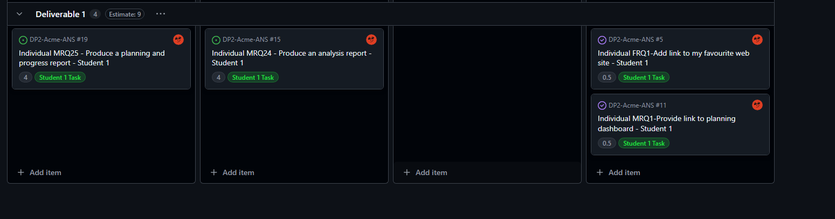

The estimated time for completing the tasks was 1 hour, with 30 minutes allocated for modifying the anonymous menu and another 30 minutes for providing the GitHub planning dashboard link. Based on an hourly rate of €20, the total estimated cost for completing these tasks is calculated as 1 hour × €20.00/hour, resulting in an estimated total cost of €20.00. This estimation reflects the expected time and cost required to complete the tasks outlined in the planning phase.

# Progress

The progress section of this report outlines the tasks and activities performed to meet the requirements for the **Acme AirNav Solutions** project. It includes a detailed description of the tasks completed, the time estimated versus the actual time spent, and a budget estimation based on the hourly rate.

In order to track the time each task took, I used Clockify.

|  |  |  |  |
| --- | --- | --- | --- |
| Task | Description | Planned Time | Actual Time |
| Modify the Anonymous Menu | Modify the menu to show an option linking to my favorite website. The title must display my ID, surname, and name. | 30 min | 30 min |
| Providing GitHub Planning Dashboard Link | Share the dashboard for tracking tasks and schedule. | 30 min | 10 min |

The final cost of the project was lower than the initial budget estimation. While the total estimated time was **1 hour**, the actual time spent was **40 minutes**—with **30 minutes** used for modifying the anonymous menu and only **10 minutes** required for providing the GitHub planning dashboard link. Since the hourly rate is **€20**, the actual cost amounted to **€13.33** instead of the estimated **€20.00**. This reduction in cost was due to completing the second task more efficiently than planned.

# Conclusions

This report outlines the planning and progress of the tasks completed for the **Acme AirNav Solutions** project. The tasks were carried out efficiently, with the actual completion time being less than originally estimated. As a result, the final cost was lower than the initial budget, highlighting effective time management and task optimization. No conflicts arose during the process, and all objectives were successfully met.

# Bibliography

Intentionally blank.